ICTWEB513 - Q1.15

# Table of contents

# 

**Table of contents** **2**

**Executive summary** **3**

**HTML** **4**

**CSS** **5**

**PHP** **6**

**MYSQL** **9**

**Javascript** **11**

# 

# Executive summary

This is a document to describe the methods involved in debugging a website that I use.

# HTML

We can submit the code to online validators such as:

<https://validator.w3.org/>  
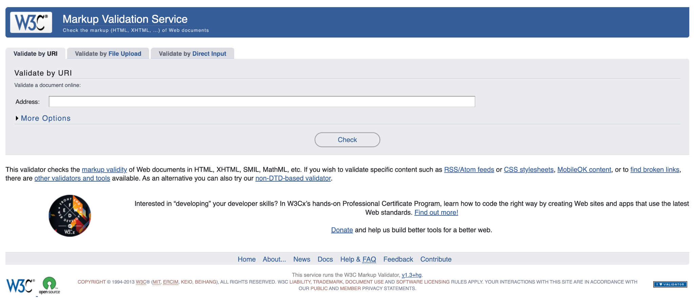

1 - Select one of the methods of validation  
2 - input the content to be validated through the field on the screen

3 - click Check

Result:

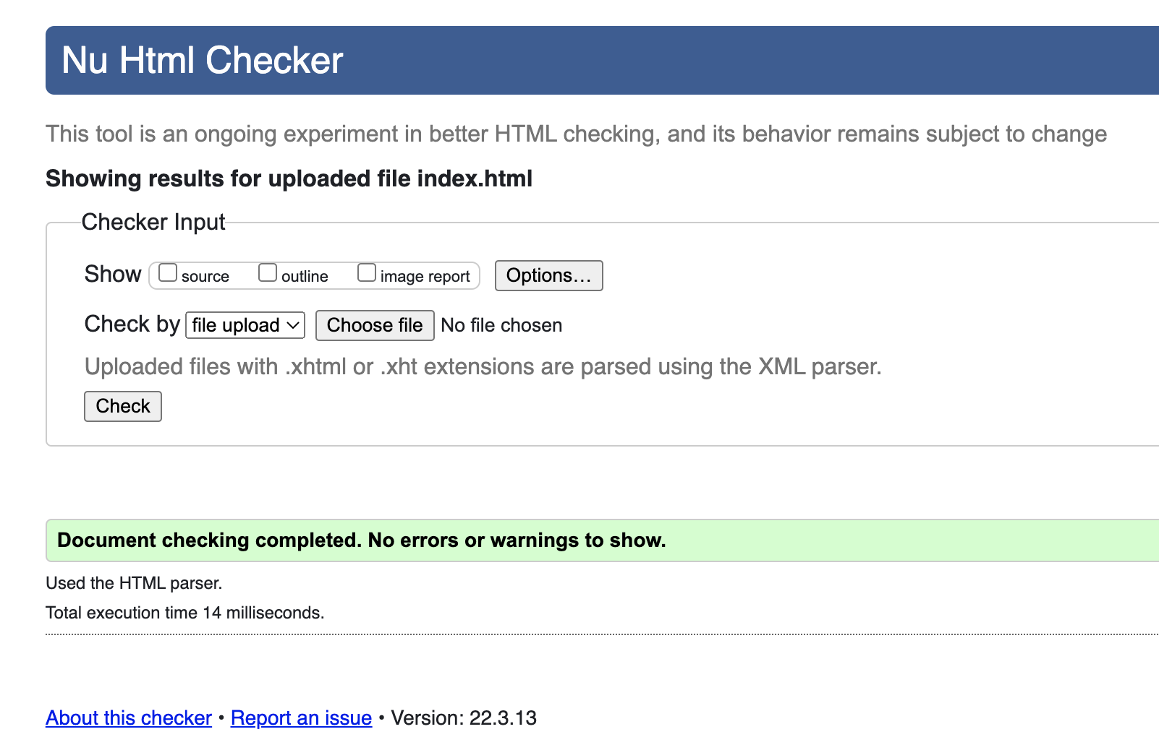

# CSS

We can submit the code to online validators such as:

<http://jigsaw.w3.org/css-validator/>

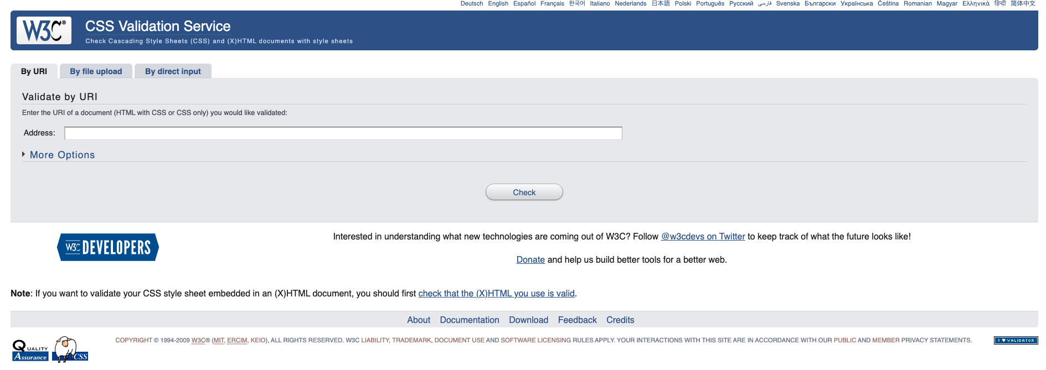

1 - Select one of the methods of validation  
2 - input the content to be validated through the field on the screen

3 - click Check

Result:

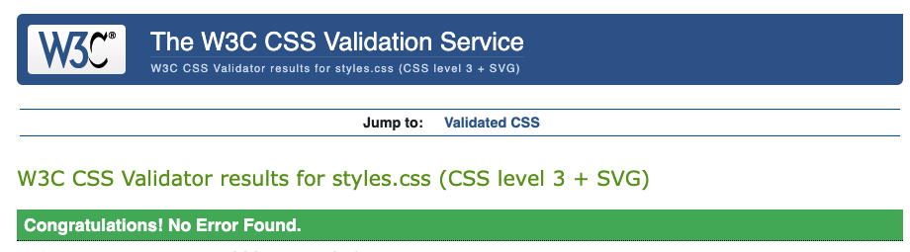

# 

# PHP

Official documentation on how to debug PHP code:

<https://www.php.net/manual/en/debugger.php>

Debugging tool:

VS CODE - PHP Debug

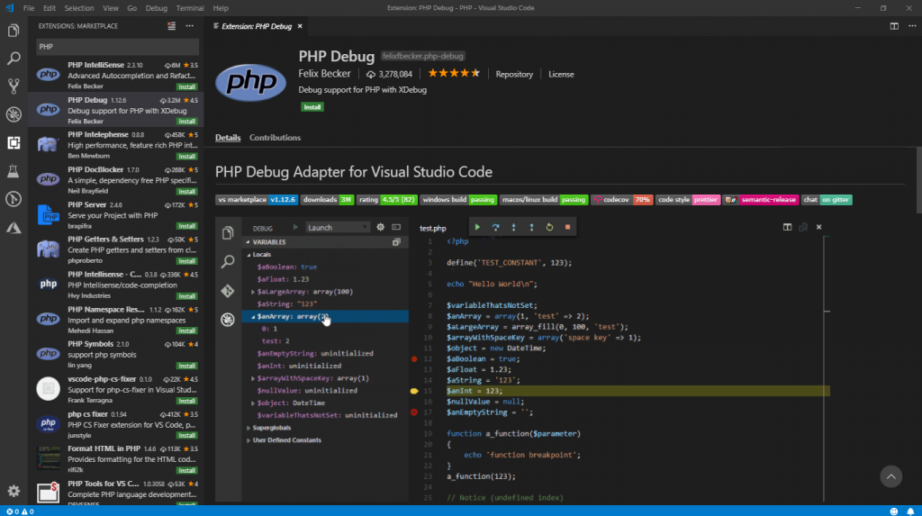

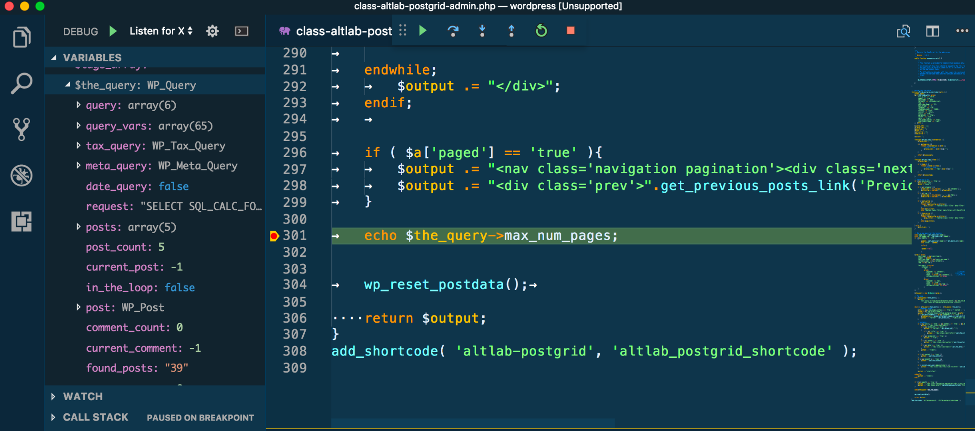

PHP Debugging for ATOM

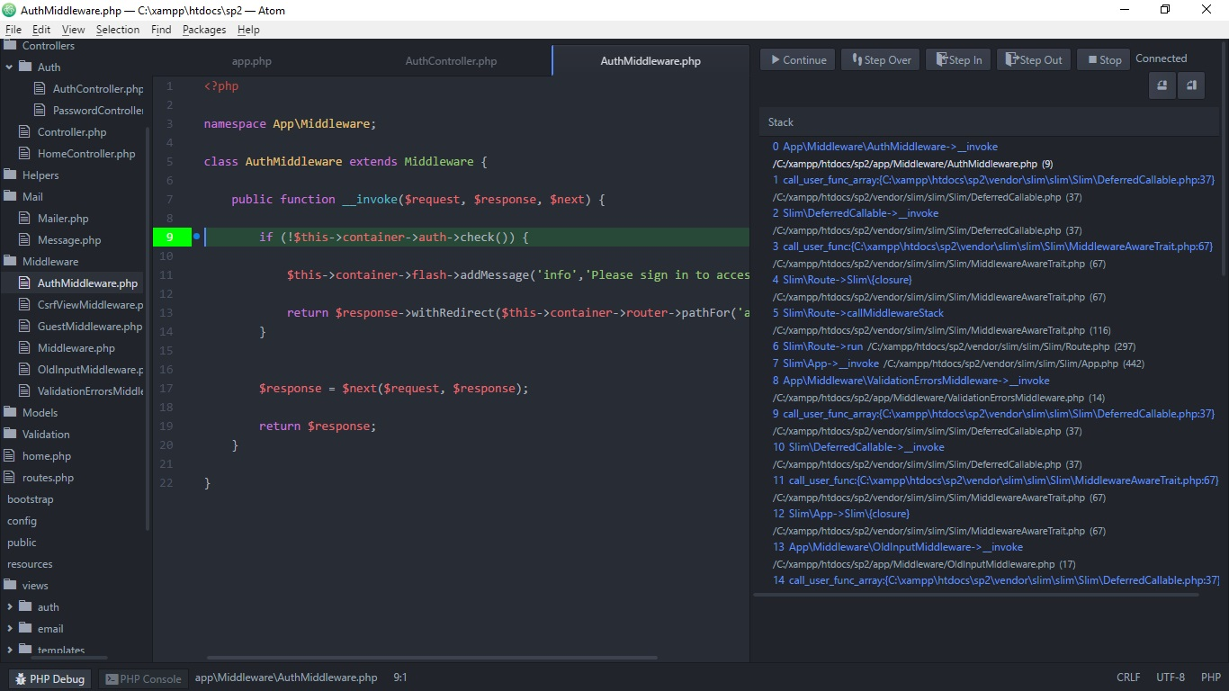

# MYSQL

Official documentation:

<https://dev.mysql.com/doc/refman/8.0/en/debugging-server.html>

Debugging tools:

Microsoft Visual Studio

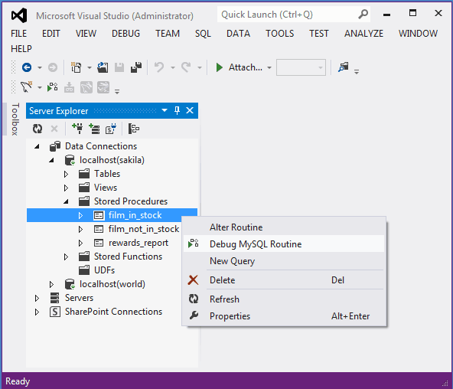

dbForge Studio for MySQL

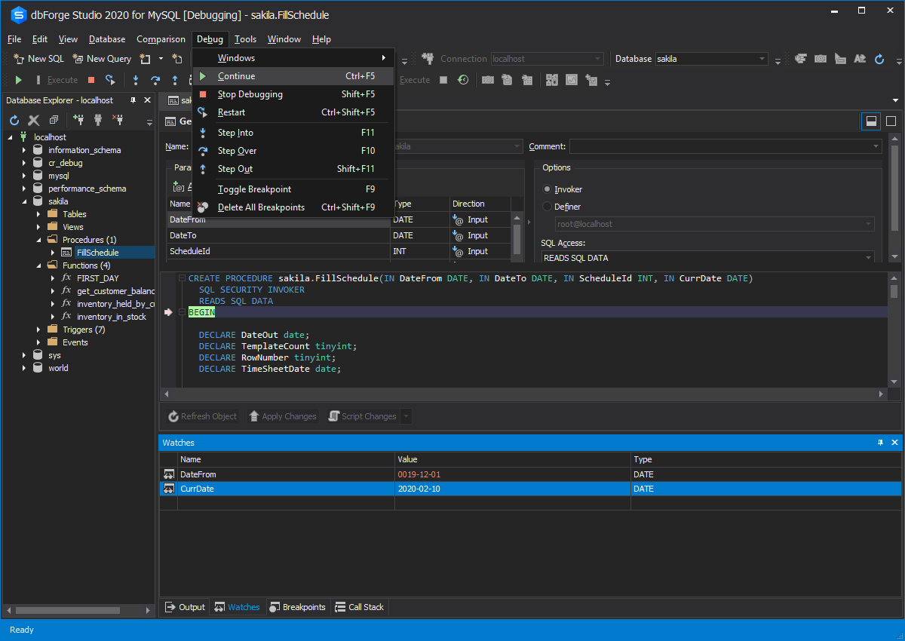

# Javascript

Modern browsers have an embedded tool for debugging, easily accessed by pressing F12:

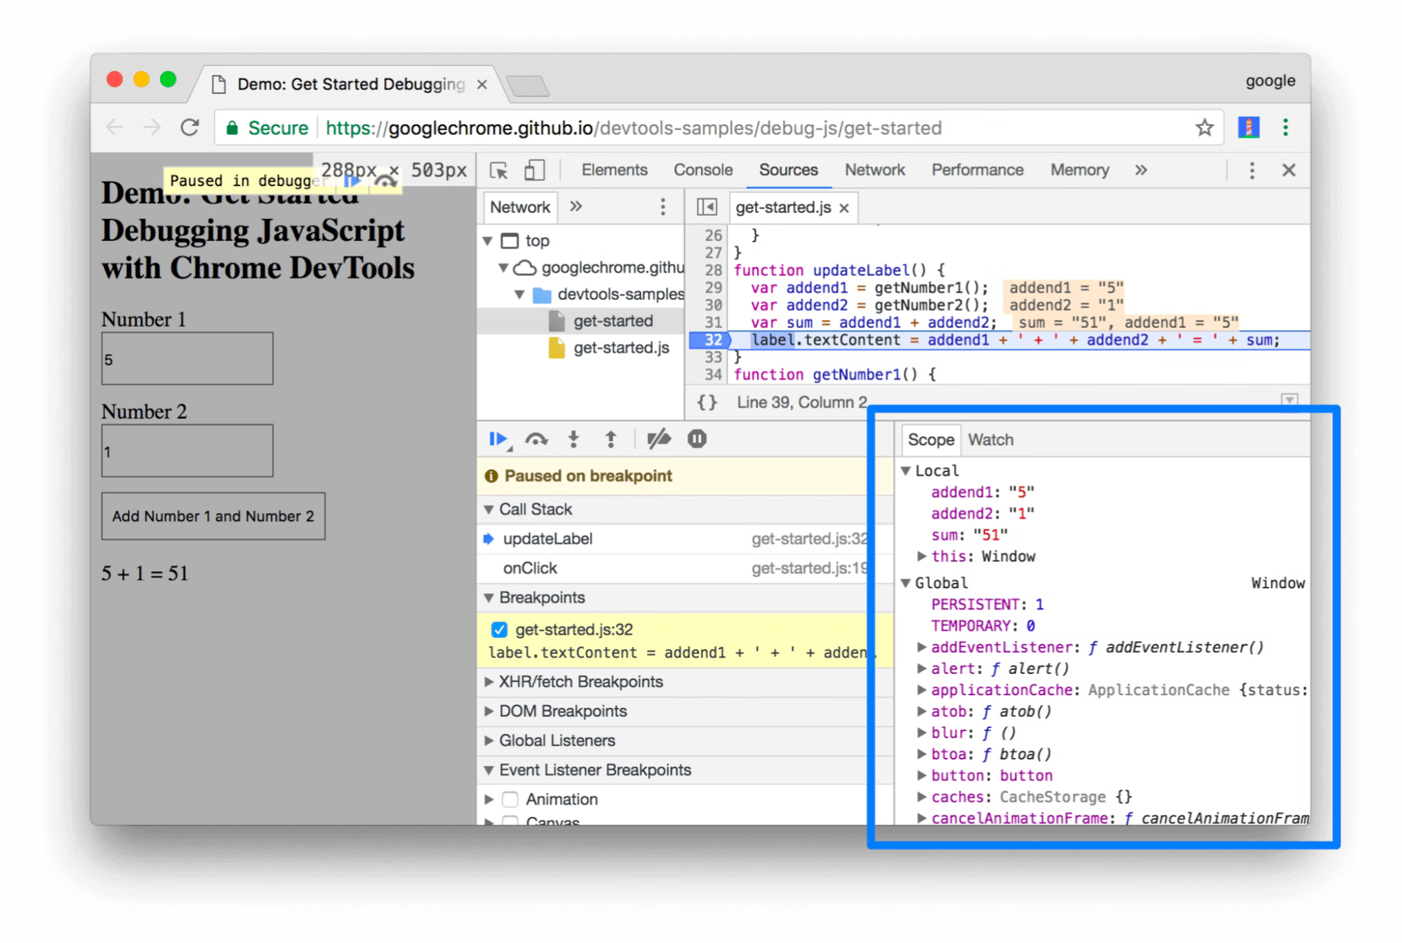

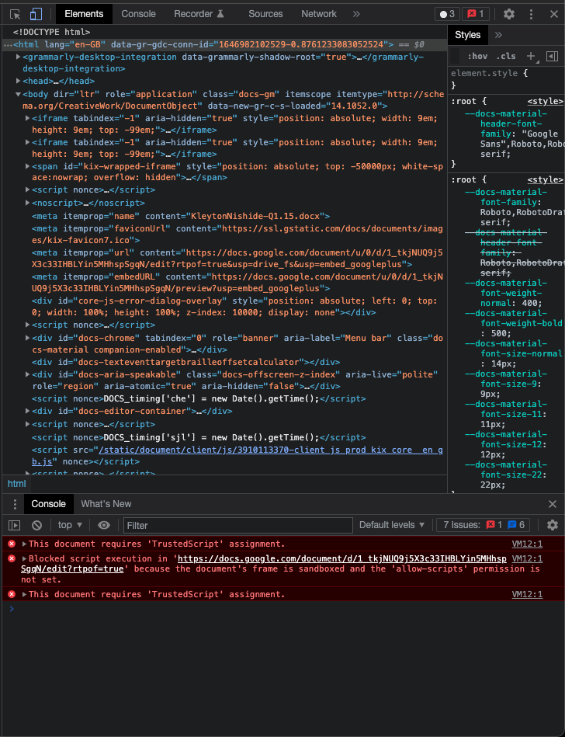

VS CODE

